**Department of Science and Technology**

**G H Raisoni Institute of Engineering & Technology Nagpur**

(Approved by AICTE, New Delhi and Recognized by DTE, Maharashtra)

An Autonomous Institute Affiliated to Rashtrasant Tukadoji Maharaj Nagpur University, Nagpur

**Accredited by NAAC with A+ Grade**

**Session: 2023-2024**

Project Synopsis

On

**“Website for Spotting Parking in Urban Areas”**

***This Synopsis is submitted to G H Raisoni Institute of Engineering & Technology, Nagpur***

***In partial fulfillment of the requirement for the award of degree of***

**“*Bachelor of Computer Application”***



*Submitted by*

|  |  |
| --- | --- |
| Mr. Charanjot Singh | Mr. Amritpal Singh |
| Mr. Shivam Deotale | Mr. Ayush Mandpe |
| Mr. Amruj Lende | Mr. Gagan Bisen |

*Under the guidance of*

**Prof. Anupam Chaube**

(Guide)

**G H RAISONI INSTITUTE OF ENGINEERING & TECHNOLOGY**

(Approved by AICTE, New Delhi and Recognized by DTE, Maharashtra)

An Autonomous Institute Affiliated to Rashtrasant Tukadoji Maharaj Nagpur University, Nagpur

**Accredited by NAAC with A+ Grade**

We, the below mentioned students of Final year Bachelor of Computer Application Department, wish to undergo the projecttitled **‘Website for Spotting Parking in Urban Areas’** under the guidance of **Mr. Anupam Chaube** for the **session 2023-24**

|  |  |  |
| --- | --- | --- |
| **Roll No.** | **Name of Student** | **Signature** |
| **059** | Mr. Charanjot Singh |  |
| **208** | Mr. Shivam Deotale |  |
| **031** | Mr. Amruj Lende |  |
| **030** | Mr. Amritpal Singh |  |
| **004** | Mr. Ayush Mandpe |  |
| **076** | Mr. Gagan Bisen |  |

**Prof. Anupam Chaube**

(Guide)

**Assistant Professor**

**Department of Science and Technology**

Prof. Anupam Chaube

**Department of Science and Technology**

**Index**

|  |  |
| --- | --- |
| **Sr. No.** | **Topic** |
| 1. | Aim of project |
| 2. | Introduction |
| 3. | Literature Survey |
| 4. | Problem Statement |
| 5. | Objective of Project |
| 6. | Block Diagram /DFD and ER Diagram |
| 7. | Result & Discussion |
| 8. | Work plan |
| 9. | Work Done |
| 10. | Conclusion (Till Date) |
| 11. | References |

**Aim of the Project**

1. Simplify Parking Search: Develop a website that simplifies the process of finding parking areas in urban environments.

2. Accurate Information: Provide users with accurate and up-to-date information about parking options near their desired location.

3. User Convenience: Offer a user-friendly interface that allows users to easily search for parking areas and make informed decisions.

4. User Reviews and Ratings: Enable users to leave reviews and ratings for parking areas they have used, enhancing the decision-making process for others.

5. Administrative Functionality: Implement an administration login feature that allows authorized users to add new parking areas to the database, ensuring the website's information remains comprehensive and current.

**Introduction**

The Urban Spotter project aims to simplify urban parking by offering a user-friendly website that provides accurate information on nearby parking areas. With a focus on user convenience, the platform allows users to search for parking spots effortlessly, aided by user reviews and ratings. Administrators can add new parking areas to ensure the database remains comprehensive. By integrating maps, the website enhances visual navigation for users. Through robust technological solutions and a responsive design, Urban Spotter strives to address urban parking challenges effectively while providing a reliable solution for commuters in bustling city environments..

**Literature Survey**

1. Existing Parking Finder Websites:

- Review existing parking finder websites such as ParkWhiz, SpotHero, and Parkopedia to understand their features, user interface, and functionalities.

- Analyze user feedback and reviews to identify strengths and weaknesses of current solutions.

2. User Needs and Preferences:

- Conduct surveys or interviews with urban commuters to understand their parking preferences, pain points, and expectations from a parking finder website.

- Explore academic papers or articles discussing user behavior and preferences related to parking in urban areas.

3. Technological Solutions:

- Investigate technologies and frameworks commonly used in web development for building similar platforms, including frontend technologies like HTML, CSS, JavaScript, and backend technologies like PHP, MySQL, and Google Maps API.

- Research advancements in map integration, user authentication, and database management to incorporate the latest technologies into the Urban Spotter project.

**Problem Statement**

**1. Parking Space Availability:**

Many urban areas suffer from a lack of available parking spaces, leading to frustration and wasted time for drivers searching for suitable parking spots.

**2. Inefficient Parking Search Process:**

The current methods for finding parking areas, such as relying on word-of-mouth recommendations or driving around aimlessly, are often time-consuming and ineffective.

**3. Safety Concerns:**

Some parking areas may be poorly lit or located in unsafe neighborhoods, posing a risk to drivers and their vehicles.

**4. Limited Access to Information:**

There may be a lack of centralized and up-to-date information about available parking areas, making it difficult for drivers to make informed decisions.

**5. Need for Community Involvement:**

While there may be hidden gems of parking spots known to locals, there is often no platform for sharing this information with a wider audience.

**Objective of the Project**

**The objectives of proposed work are as follows:**

* Simplify the parking experience by providing a straightforward and user-friendly platform.
* Reduce the time and stress associated with finding parking spaces.
* Focus on user satisfaction by ensuring cost structures,secure reservations, and a platform that incorporates user feedback.
* Our goal is to provide accessible parking options, including features for individuals with specific requirements,ensuring convenience for all user.

|  |
| --- |
|  |

**Block Diagram**

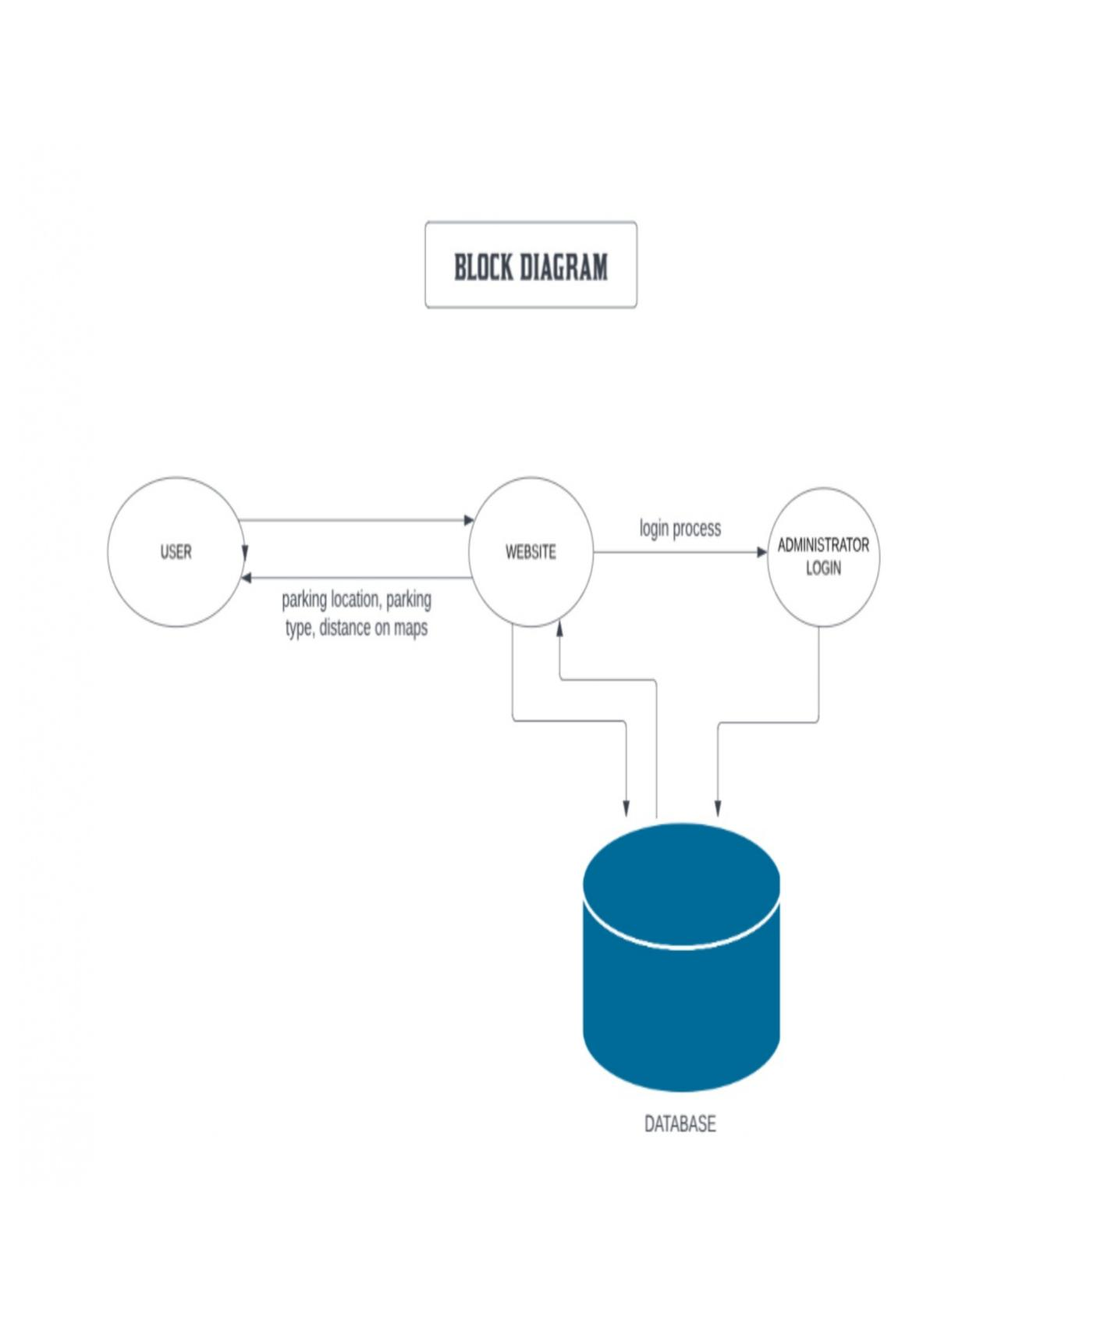

**Result and Discussion**

* Discussed about the problems which is faced by many of the people while parking their vehicle.
* Discussed about database for keeping each and every details of the user secure in the website.
* Discussed about the linking of database with the website.

**Work plan**

|  |  |  |  |  |
| --- | --- | --- | --- | --- |
| **Months Activities** | **JAN’23** | **FEB’23** | **MAR’23** | **APR’23** |
| **Project Reviews** | **√** |  |  |  |
| **Component Identification & Selection** |  | **√** |  |  |
| **Designing** |  | **√** |  |  |
| **Coding** |  |  |  |  |
| **Experimental Analysis** |  |  |  |  |
| **Testing and Debugging** |  |  |  |  |
| **Preparation of Project Report** |  |  |  |  |
| **Thesis Submission** |  |  |  |  |

**WorkDone**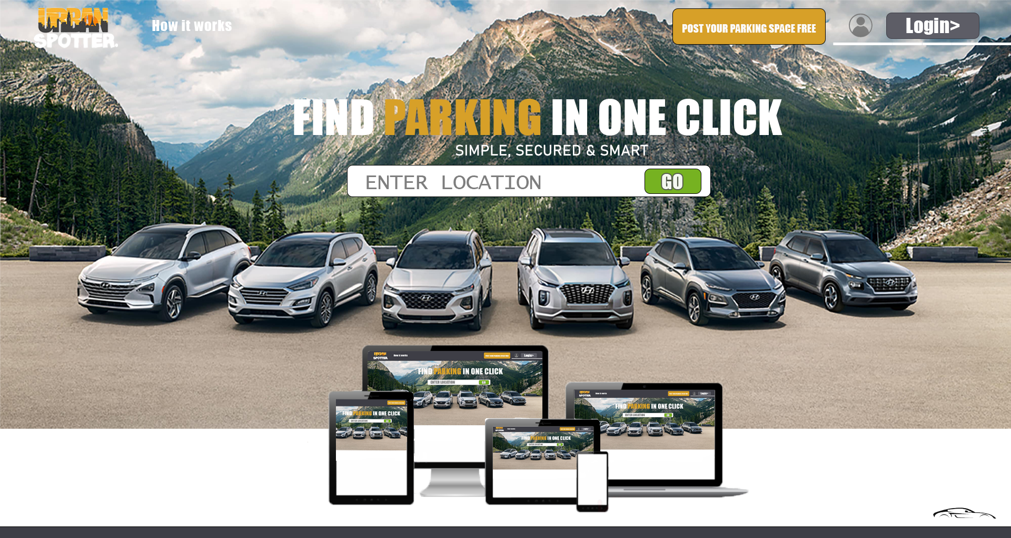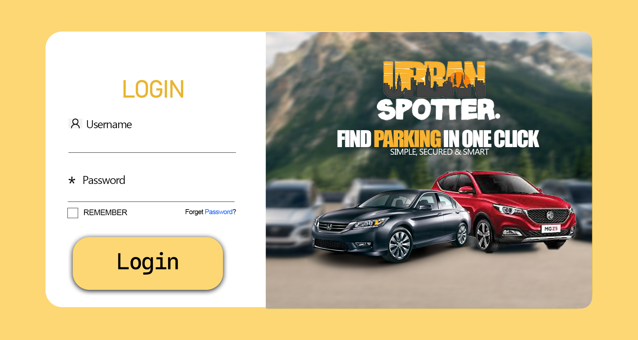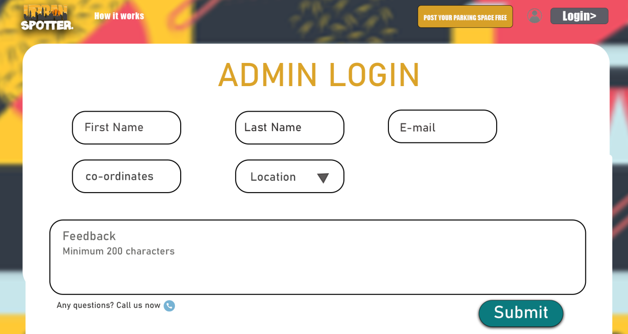

**Conclusion (Till Date)**

Urban Spotter aims to revolutionize the parking experience by providing a user-friendly platform that simplifiesnthe process of finding and reserving parking spaces.Through the integration of advanced technology,transparent cost structure,and user driven feedback,we strive to offer a seamless and efficient solution for users seeking convenient and stress-free parking.Urban Spotter aspires to redefine the way individuals approach and experience parking,making it a positive and integral part of their journey.Join us on this journey towards a future where parking is not just a necessity but a hassle-free and enjoyable experience**.**

**Reference**

**Online Websites Reviews**

**Dribble:**

**<https://dribbble.com/>**

We used dribble website for the references and for the UI design.